BÁO CÁO TẠO ĐỒ THỊ CHƯƠNG TRÌNH

Tên công cụ: eclipse plugin cfg.

Ngôn ngữ: Java.

Yêu cầu: sử dụng phần mềm eclipse.

Link install software: <http://eclipsefcg.sourceforge.net/>

<http://update.codecover.org/>

Code Example :

**public** **class** GiaiPtB2 {

/**

* **@param** args

*/

**public** String Giai(**int** a, **int** b, **int** c){

**int** D = b*b - 4*a*c;

**double** x = (**double**)-c/b;

String Nghiem = "";

**if**( a == 0 ){

**return** Double.*toString*((**double**)Math.*round*(x*10)/10);

}

**if**( a!= 0 && D > 0 ){

**double** x1= ( -b + Math.*sqrt*(D) ) / (2*a);

**double** x2= ( -b - Math.*sqrt*(D) ) / (2*a);

Nghiem = (**double**)Math.*round*(x1*10)/10 + ";" + (**double**)Math.*round*(x2*10)/10;

**return** Nghiem;

}

**if**( a!= 0 && D < 0 ){

**return** "err";

}

**if**( a!= 0 && D == 0 ){

x = (**double**)-b/(2*a);

Nghiem = Double.*toString*((**double**)Math.*round*(x*10)/10);

**return** Nghiem;

}

**return** "11";

}

}

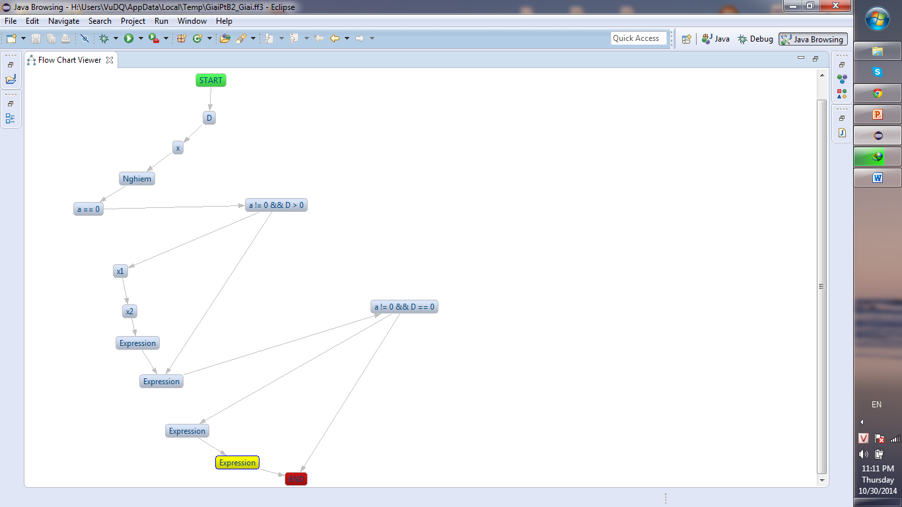

**public** **class** Simple {

**public** **void** SosSanh(**int** a, **int** b){

**if**( a == b )

System.***out***.println("a=b");

**else** **if**( a > b)

System.***out***.println("a>b");

**else**

System.***out***.println("a<b");

}

}

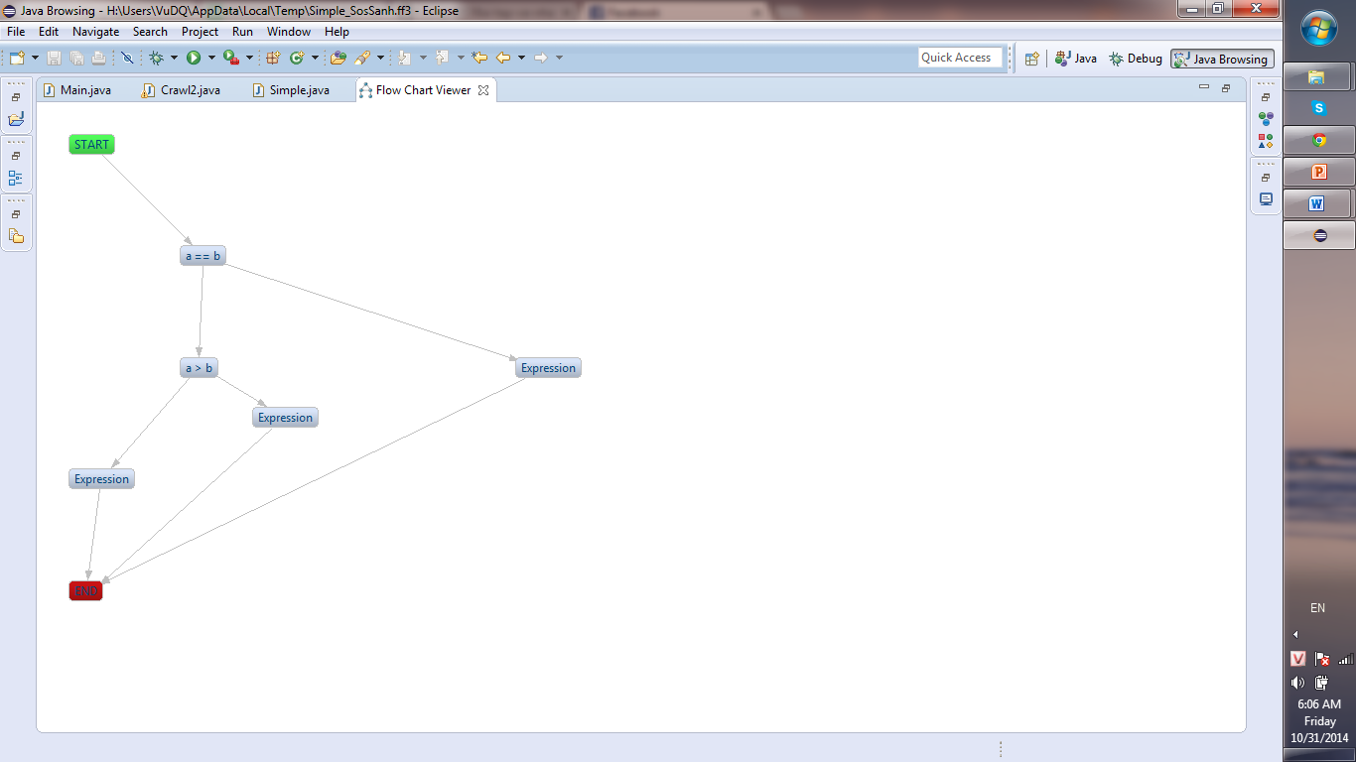

C1P test case:

1. (1,1)
2. (2,1)
3. (1,2)